**DARLASTON MEDICAL CENTRE**

|  |  |  |  |
| --- | --- | --- | --- |
| **OPENING TIMES** | | | |
| **MONDAY** | **08:00** | **-** | **18:30** |
| **TUESDAY** | **08:00** | **-** | **18:30** |
| **WEDNESDAY** | **08:00** | **-** | **18:30** |
| **THURSDAY** | **08:00** | **-** | **14:00** |
| **FRIDAY** | **08:00** | **-** | **18:30** |

Dr Tahira Ismat – (Partner) MBBS MRCGP

Dr Syed Tariq Imam- (Partner) MSc, MBBS, MRCS, MRCGP

Dr Haris Syed MBBS TGP

Lisa Ali ( Practice Nurse) BACHELOR OF NURSING WITH HONOURS IN ADULT NURSING, ADV DIPLOMA IN GENERAL PRACTICE NURSING

Noorun Miah (Health Care Assistant)

Darlaston Medical Centre, Birmingham Street, Darlaston, West Midlands WS10 9JQ

Telephone: 0121 526 7151 Email: [darlaston.medicalcentre@nhs.net](mailto:darlaston.medicalcentre@nhs.net)

www.darlastonmedicalcentre.co.uk

PRACTICE LEAFLET



**H**

l

a

**e**

c

**a**

i

**l**

d

**t**

e

**h**

M

**C**

**a**

**r**

**e**

**D**

**a**

**r**

**l**

**a**

e

**s**

c

**t**

i

t

**o**

c

a

**n**

r

P

D

**ABOUT YOUR PRACTICE**

**Physiotherapist C.P.N**

**Pharmacist**

**Office Manager**

**Secretary**

**H.C.A**

**Practice Nurse**

**Practice Manager**

**Receptionist & Administrative Staff**

**ATTACHED HEALTHCARE STAFF**

**Midwife for Ante-Natal Care**

**PRACTICE STAFF**

**GENERAL PRACTIONERS**

Dr Tahira Ismat

**General Practitioner**

Female Doctor

Dr Haris Syed

**General Practitioner**

Male Doctor

Dr Syed Tariq Imam

**General Practitioner**

Male Doctor

**WHEN WE’RE NOT OPEN & EXTENDED GP ACCESS**

Any telephone calls made between the hours of 13:00 to 18:30 on Thursday afternoons are automatically diverted to Walsall Ournet who provide services on behalf of the Practice.

**Between 6:30pm and 8:00am services are provided by the BCICB. You can** call 111 for medical advice. If you feel the condition is life threatening, please call 999.

Walsall ICB provides GP access at four hubs based at Darlaston Heath Centre, Pinfold Health Centre, Broadway Medical Centre and Portland Medical Practice.

Appointments will be available:

* 16:30 to 19:00 Weekdays

To book an appointment call 01922 501999 during the following times

* 08:00 to 21:00 Weekdays
* 10:00 to 15:00 Weekends
* 11.00 to 13:00 Bank Holidays

NHS 111 will also be able to book an appointment for you if they feel you need to

see a GP.

### HOW TO REGISTER AS A PATIENT

The practice accepts patients within the practice area. (map on back page). This practice does not discriminate on grounds of race, gender, age, social class, religion, sexual orientation, appearance or medical condition.

If you wish to register at the Practice please ask at our Reception and forms are also available to download from website

Following your registration, you will be asked to book in for a new patient health check.

### MAKING AN APPOINTMENT

GP and Nurse Clinics are booked by appointment only. Appointments are offered via our online triage system, Accurx Triage, which is available on our website. All other routine appointments can be made in person, telephone or via the online triage. For more information, please speak to someone from our Reception Team.

If you are unable to attend for your appointment, please let us know within 24 hours so that we can offer this appointment to another patient.

The Practice uses a messaging system called Accurx which reminds you of your appointments and gives you the ability to cancel your appointment via your mobile phone. Therefore, it is essential we always have an up to date mobile number.

Appointments are available at 09:00 every day and **on the day appointments are not booked at the reception window.**

#### REPEAT PRESCRIPTIONS AND MEDICAL RECORDS

We **do not** take any prescription requests over the phone unless you are housebound or over the age of 70. Repeat prescriptions requests can also be made via email, through your nominated pharmacy or by leaving your requests in our prescription box located in the entrance.

If you wish to review your medical records online or require any further details please ask at reception.

### URGENT APPOINTMENTS

We have urgent appointments available each day for the GPs. They are provided on a ‘first come, first serve’ basis. Emergencies will be seen the same day, at the end of Surgery, but this may involve a wait.

**(Urgent appointments are not for Repeat Prescriptions, fitness for work certificates or for signing forms).**

### HOME VISITS

Home visits should only be requested for those who are unable to come to the Surgery because of serious illness and infirmity. They should be requested via a telephone consultation before 11:00 if at all possible. This will help the Doctor plan his visits.

### PRESCRIPTIONS

**ROUTINE -** Requests for repeat prescriptions will be dealt with within 2 working days. To avoid any risk of error, requests need to state the items required along with dosage and quantity and stating from where they will be collected. Outside of surgery hours requests can be posted into the black ‘Prescription Request’ box found on the right-hand side of the Practice Entrance. From time to time, the Doctor will ask you to make an appointment to review your repeat medication. Repeat prescription requests can also be made via email, through your nominated pharmacy, or by leaving your requests in our prescription box located at the entrance.

**OVER 70’s & HOUSEBOUND -** Prescription requests will be taken over the phone.

### CHAPERONES

All patients are entitled to have a chaperone present for any consultation. Please request this at the time of booking or speak to your GP.

### ACCOUNTABLE GP

All patients have a ‘named accountable GP’ in person and which will either be Dr Tahira Ismat or Dr S T Imam. All patients will be informed via ACCURX text messaging service or upon request at Reception. New patients will be informed at their New Patient Health Check. You are allowed to make an appointment to see any GP. Please enquire at Reception for further information.

### PRACTICE NURSE & HEALTH CARE ASSISTANT

We have a Practice Nurse & H.C.A. available every day that holds all disease management/health promotion clinics and carries out vaccinations and dressings.

### MISSED APPOINTMENTS

If you do not attend 3 or more appointments within a year with, you will be removed from the Practice.

### CLINIC & SERVICES

The Practice offers a full range of health promotion and disease management

clinics. These include clinics for the following;

**Asthma, COPD, Diabetes, Heart Risk, Hypertension, Epilepsy, Thyroid Problems, NHS Health Checks, Smoking Cessation, Weight Management and**

**Cervical Smear Tests, Travel Vaccination, Mental Health Reviews, Learning Disability Reviews, Child and Adult Vaccinations** Appointments are required.

### ANTE-NATAL CLINIC

This is held every Friday by the Midwife. An appointment is required.

### BABY CLINIC

All child immunisations and development screening is carried out by the Practice Nurse. Appointments are necessary.

#### FAMILY PLANNING, PRE-CONCEPTUALADVICE, EMERGENCY CONTRACEPTION

**(morning after pill)**

Appointments to be made with the Doctor or Practice Nurse.

### YOUR RESPONSIBILITIES

* To keep your appointments and arrive on time.
* Ensure you inform us of the change of name, address, and telephone number.
* Treat us with respect and courtesy.
* Take responsibility for your own health.
* Take our advice about a healthy lifestyle.

### OUR RESPONSIBILITIES

* To treat you with respect and courtesy.
* Advise you on your health needs
* Explain your treatment
* Maintain the strictest confidentiality regarding your medical records.

### VIOLENT & AGGRESSIVE PATIENTS

The practice operates a zero-tolerance policy. We will not tolerate abuse, and the practice has the right to remove violent patients from the list immediately to safeguard our staff and other patients. Violence in this context includes actual or threatened physical behavior or verbal abuse, putting others in fear.

### SUGGESTIONS & COMPLAINTS

The practice welcomes your comments & suggestions. There is a box in the waiting room for you to post your comments. If you have any complaints about any aspect of our service, please write or email the surgery addressing your complaint to the Complaints Manager, who will investigate your complaint. If you do not wish to contact the surgery directly regarding your complaint, you can choose to contact Time2Talk. You can contact Time2Talk by post: Time2Talk, NHS Black Country Integrated Care Board (ICB) Civic Centre, St Peter’s Square, Wolverhampton, WV1 1SH. By email: [bcicb.time2talk@nhs.net](mailto:bcicb.time2talk@nhs.net) or by phone :0300 0120 281 and select Option 4.

Please find further information on their website: https://[www.england.nhs.uk/](http://www.england.nhs.uk/)

contact-us/complaint/

If you require any guidance in making a complaint, please contact **The Parliamentary and Health Service Ombudsman,** Millbank Tower, Millbank, London, SW1P 4QP. Tel: 0345 015 4033.

### CONFIDENTIALITY & ACCESS TO MEDICAL RECORDS

All patient information is kept according to strict laws governing personal information. We do not give any information to outside agencies unless we have written consent from the patient. For more information, speak to a member of staff from Reception. If you wish to see your medical records, this can be arranged by completing a ‘Patient Access to Medical Record Form’.

### OUR AIMS

Our aims are to offer our patients the highest standard of health care and advice with the resources available to us. We have a team approach to patient care and endeavor to monitor the service provided to patients, to ensure that it meets current standards of excellence. We are dedicated to ensuring that Practice staff and Doctors are trained to the highest level and provide a stimulating and rewarding environment to work.

### RESULTS OF TESTS

Please contact the surgery five working days after blood tests have been taken. For other test results, call the surgery as advised by the clinician. The receptionist will not be able to discuss results, and you may be asked to make an appointment to see the doctor. You will also receive a text message from the Doctor when the results have been viewed. All results are provided with a routine appointment unless advised by the GP.

Results can also be accessed via Online Services such as the NHS App once you have applied. Application Forms are available from Reception.

### NHS WALK-IN HEALTH CENTRE

Walsall Urgent Care Centre, Walsall Manor Hospital, Moat Road, Walsall.

### DATA PROTECTION

All information held about patients is completely confidential. The Practice is registered under the Data Protection Act 1984. This Act protects data held on the computer system.

### THE FREEDOM OF INFORMATION ACT

The Freedom of Information Act gives you the right to request information from a public sector organisation. Unless there’s a good reason, the organisation must provide the information within 20 working days. Please contact the Practice Manager.

### YOUR DATA MATTERS

Information about your health and care helps us to improve care, speed up diagnosis, plan local services, and research new treatments. You can stop your information from being used for research and planning. Ask at reception for more details. More information on https://[www.nhs.uk/your-nhs-data-matters](http://www.nhs.uk/your-nhs-data-matters)

#### OTHER LEAFLETS

You will find a wide variety of Practice Leaflets that will inform you of all our services for our patients. Please ask at Reception.

**FACILITIES**

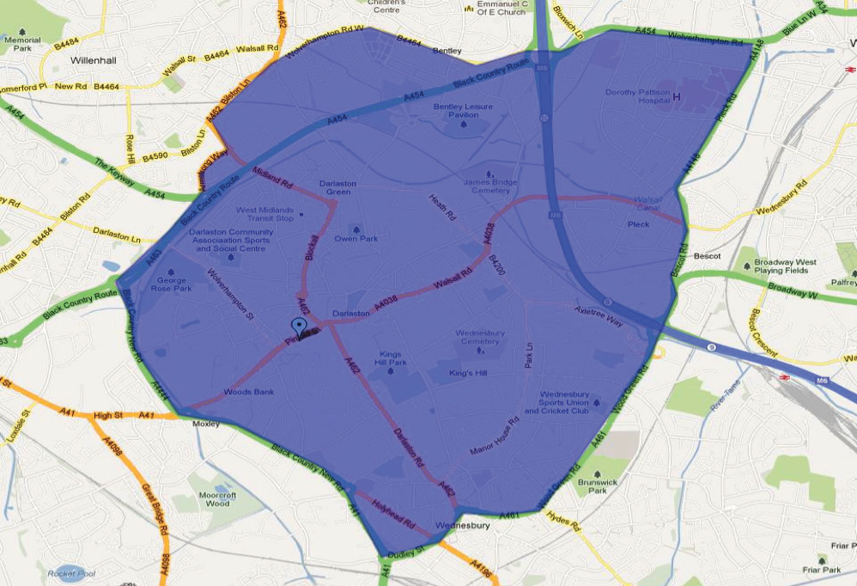

**DISABLED ACCESS**

There is suitable access to the surgery for wheelchairs, including a ramp.

Disabled toilets are also available.

**PARKING**

The car park accommodates patients, visitors and disabled badge holders.

**PUBLIC TRANSPORT**

The practice premises are accessible via local bus routes.

### PRACTICE BORDER

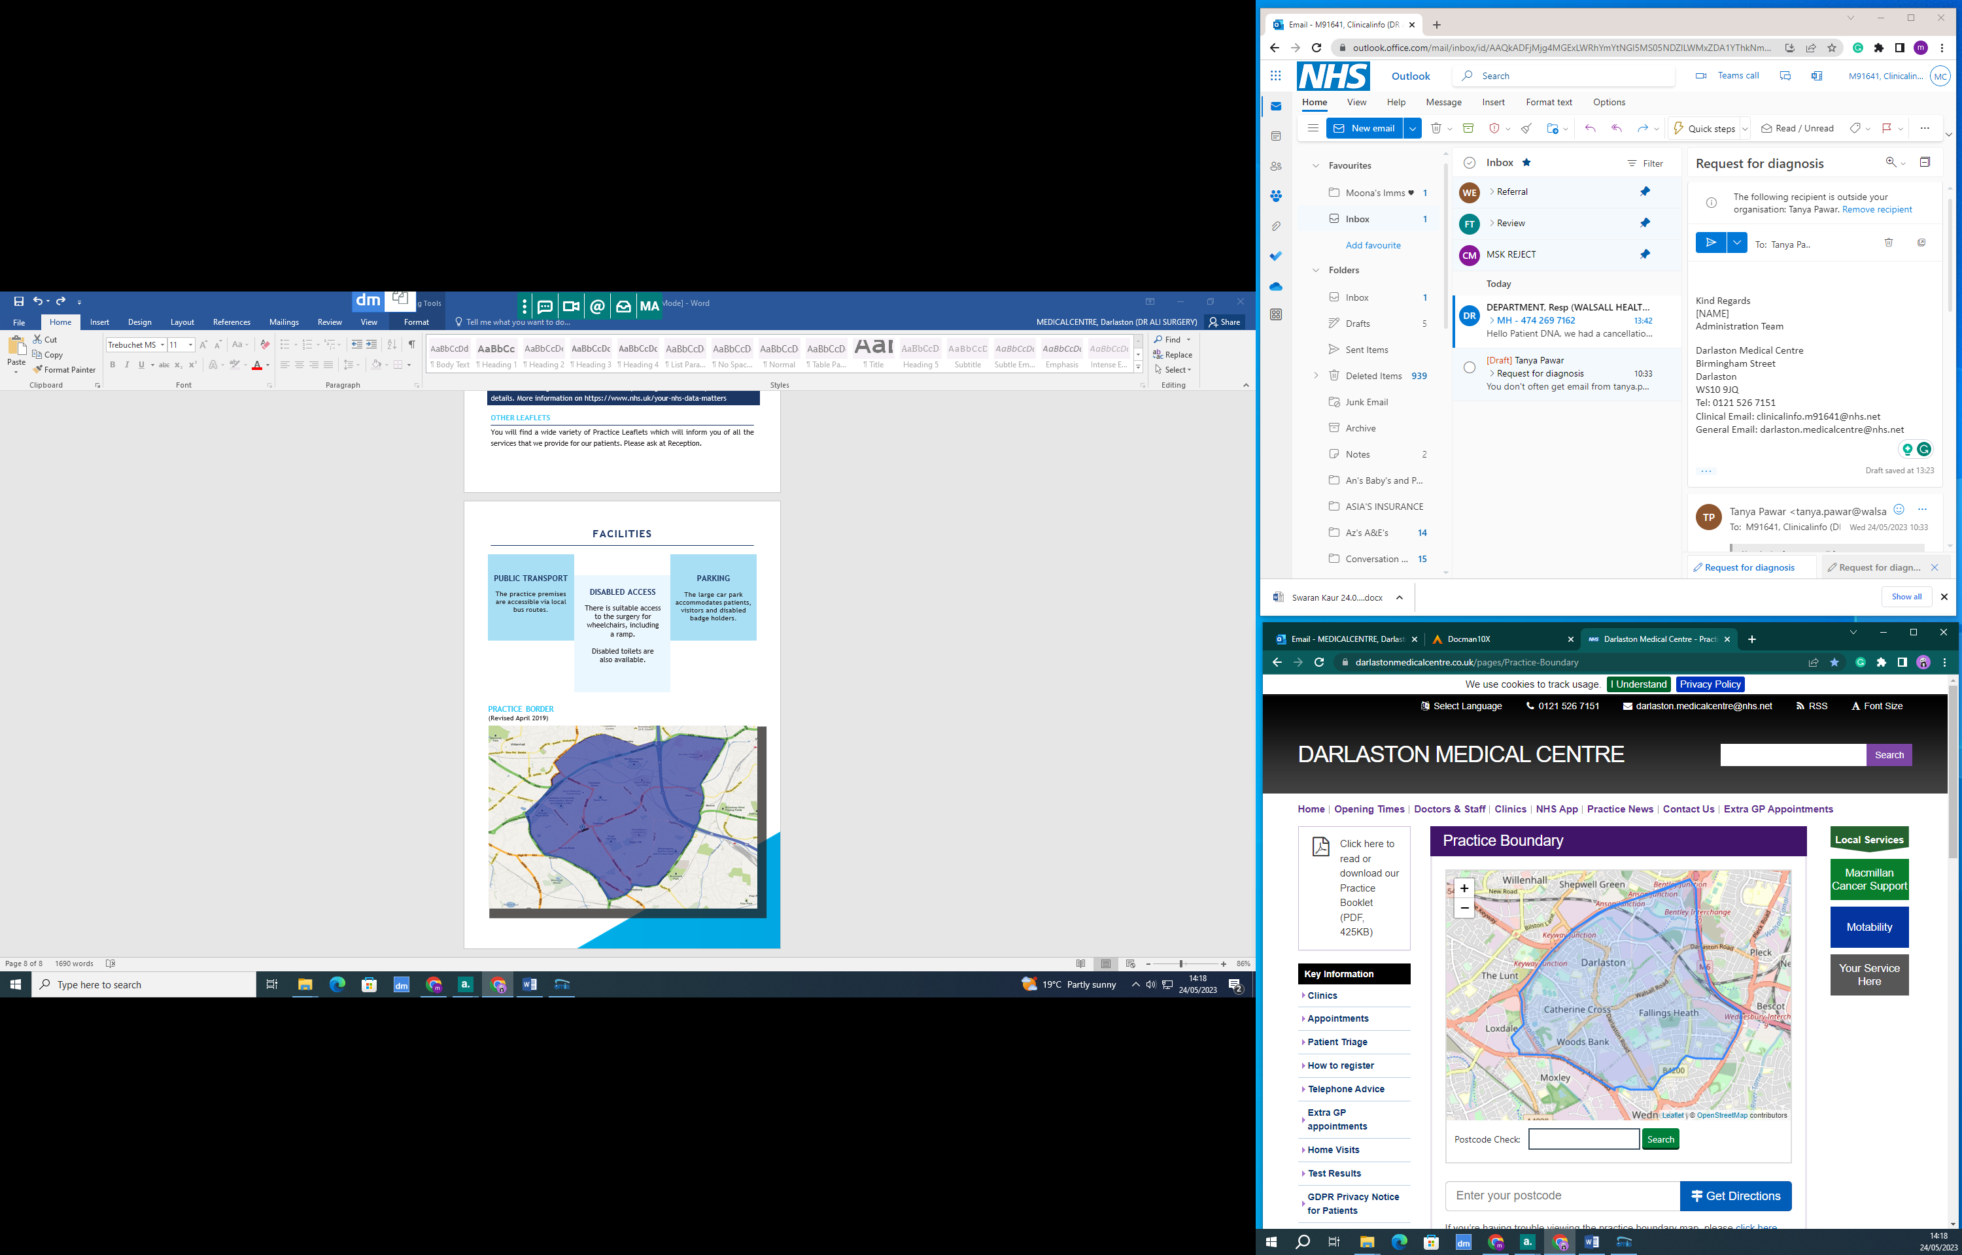

Review Date: 24.06.2024 Author: Mona