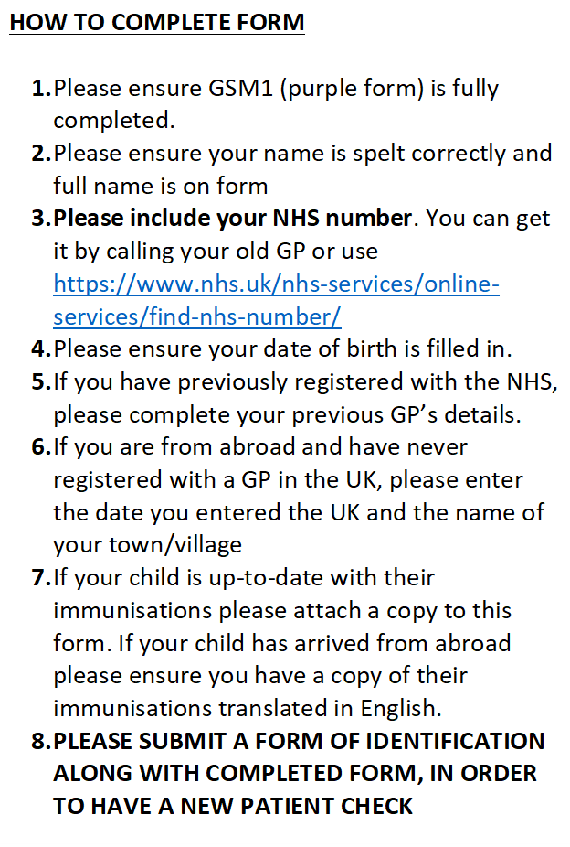

|  |  |  |  |  |  |  |
| --- | --- | --- | --- | --- | --- | --- |
| **OFFICE USE ONLY:** | | | | | | |
| Identity Documents |  | Vaccination Records |  | Medication List |  | Checked by: |

**Darlaston Medical Centre**

**Today’s Date:**

# New Patient Registration Form

|  |  |  |  |  |  |  |  |  |
| --- | --- | --- | --- | --- | --- | --- | --- | --- |
| **Full Name:** | | | | | | **Telephone Number:** | | |
| **Mr / Mrs / Miss / Ms / Other……..** | | | | | | **Work Number** | | |
| **Address and Postcode** | | | | | | **Mobile Number:** | | |
| **Date of Birth:** | | |
| **E-mail Address:** | | |  | | | | | |
| **Occupation:** | | | | | |  | | |
|  | | | | | | | | |
| **Your**  **Religion:** | **C of E** | | **Catholic** | **Other Christian (state)** | | **Buddhist** | **Hindu** | **Muslim** |
| **Sikh** | | **Jewish** | **Jehovah’s Witness** | | **No religion** | **Other religion (state)** | |
|  | | | | | | | | |
| **Your Ethnic Origin:**  **(select one)** | | | **British**  **9i0** | | **White (Irish)**  **9i1%** | | **White (Other)**  **9i2%** | |
| **Caribbean**  **9i3** | | | **African**  **9i4** | | **Asian 9i5** | | **Other Mixed**  **Background 9i6%** | |
| **Indian /**  **Brit Indian 9i7** | | | **Pakistani /**  **Brit Pakistani 9i8** | | **Bangladeshi / Brit Bangladeshi 9i9** | | **Other Asian**  **Background 9iA%** | |
| **Other Black**  **Background** | | | **Chinese**  **9iE** | | **Other**  **9iF%** | | **Ethnic Category**  **not stated 9iG** | |
|  | | | | | | | | |
| **Your Medical Background:** | | | | | | | | |
| **Do you have any medical problems or disabilities at present?** | |  | | | | | | |
| **Please list any tablets, medicines you are taking and attach a copy of list from previous GP** | |  | | | | | | |

**Summary Care Records**

**The NHS are changing the way your health information is stored and managed.**

**The NHS summary care record is an electronic record of important information about your health.**

**It will be available to health care staff providing NHS care. An information pack has been provided.**

***Your physical examination will include having your height, weight and blood pressure taken, and a specimen of urine for testing (it would be helpful if you would bring a specimen with you when coming to the Practice).***

***The Consultation will also establish relevant past medical and family history, including:***

* ***Medical factors - illnesses, immunisations, allergies, hereditary factors, screening tests, current health***
* ***Social factors - employment, housing, family circumstances***
* ***Lifestyle factors - diet and exercise, smoking, alcohol and drug abuse.***

**Thank you for completing this form**

NHS Summary Care Record with additional information

If you are registered with a GP practice in England you will have a Summary Care Record (SCR), unless you have previously chosen not to have one. It includes important information about your health:

* Medicines you are taking
* Allergies you suffer from
* Any bad reactions to medicines

You may need to be treated by health and care professionals that do not know your medical history. Essential details about your healthcare can be difficult to remember, particularly when you are unwell or have complex care needs. Having an SCR means that when you need healthcare you can be helped to recall vital information.

SCRs can help the staff involved in your care make better and safer decisions about how best to treat you.

**You can choose** to have additional information included in your SCR, which can enhance the care you receive. This information includes:

* Your illnesses and health problems
* Operations and vaccinations you have had in the past
* How you would like to be treated - such as where you would prefer to receive care
* What support you might need
* Who should be contacted for more information about you

**What to do next**

If you would like this information adding to your SCR (or the SCR of someone you are a carer for), then please complete this form, for return to the relevant GP surgery.

Name of Patient: ………………………………………………..….....................................

Date of Birth: ……………………………. Surgery Name: …………………………..

Patient’s Postcode: …………………………. Surgery Location (Town): ……….................

NHS Number (if known): …………………………..………………....................................

Signature: …………………………………………….. Date: ……………………………….

If you are filling out this form on behalf of another person, please ensure that you fill out their details above; **you** sign the form above and provide your details below:

Name: …………..............................................................................................................

|  |  |  |
| --- | --- | --- |
| Parent | Legal Guardian | Lasting power of attorney for health and welfare |

Capacity:

Please circle one

If you require any more information, please visit [**www.hscic.gov.uk/scr/patient**](http://www.hscic.gov.uk/scr/patient)

phone HSCIC on **0300 303 5678** or speak to your GP Practice

**For practice use:** To update the patient’s consent status to ‘Express consent for medication, allergies, adverse reactions and Additional Information’ use the SCR consent preference dialogue box or add Read code **9Ndn** (or CTV3 code **XaXbZ** for SystmOne practices)